**Lab Manual- SysOps with Azure CLI**

**Prepared for**:

**Date:** 18th Nov 2024

**Prepared by:** Bipin Sinhaa

Document Name: Lab Manual

**Document Number** SysOpsLab311

**Contributor:**

Shruti Sinhaa

Table of Contents

1 OBJECTIVE 2

2 PRE-REQUISISTE 3

3 Setup Up Azure CLI in Cloud Shell 3

3.1 **Azure Resource Group** 5

3.2 **Azure VM Comamnd** 6

# OBJECTIVE

Azure CLI is a cross-platform command line tool, that is used to manage and administrate Microsoft Azure. It doesn’t replace PowerShell but provides an alternative to using managing Azure from the command line. You can still continue using PowerShell, the APIs and the Azure Portal just like before. Azure CLI provides some tangible benefits over these, especially over PowerShell in that it’s very nimble and can be quickly installed on almost any platform.This Lab will cover the basics of configuring Azure cli.

Actually an Azure CLI command has the following structure:

* **a command group** which represents an Azure service and which can be the composition of subgroups
* **a command** which is the action you want to do on the group / Azure service
* arguments optionally which are a list of parameter names and values

# PRE-REQUISISTE

* Accounts in Azure
* A local Computer with 4 CPU, 16 GB RAM, 200 GB disk space

# Setup Up Azure CLI in Cloud Shell

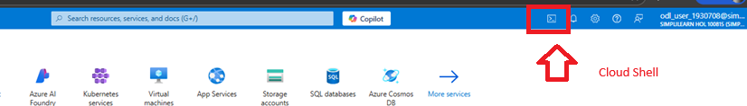

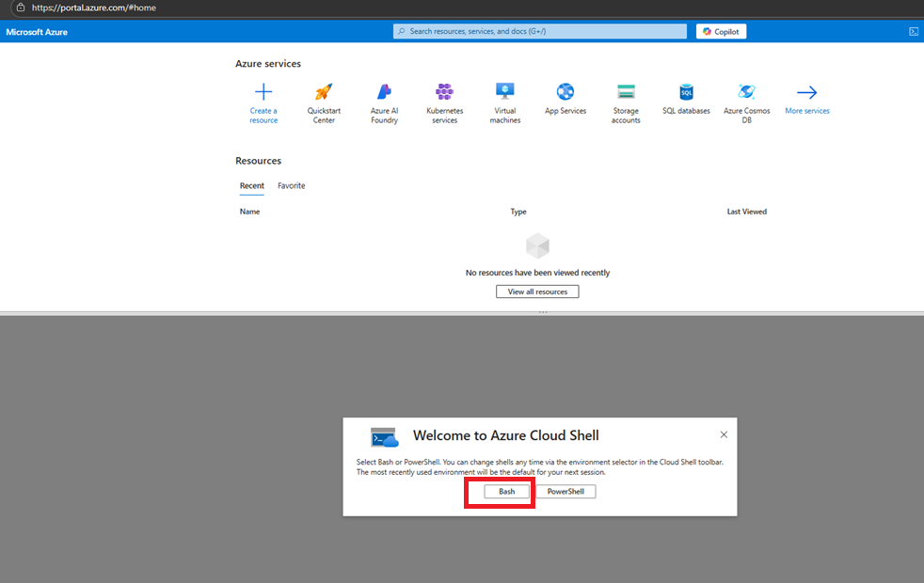

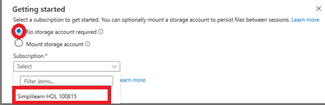

## **Azure Resource Group**

To list all Resource Groups, use:

az group list --output table

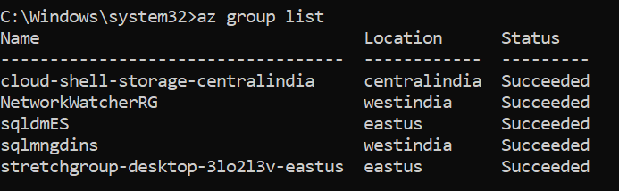

To create a new Resource Group Name **Azclidemo** at **eastuse** region , type:

**az group create --name bipeenRG --location westus2**

Now list the resources group again to see your created Resources group **Azclidemo**

az group list --output table

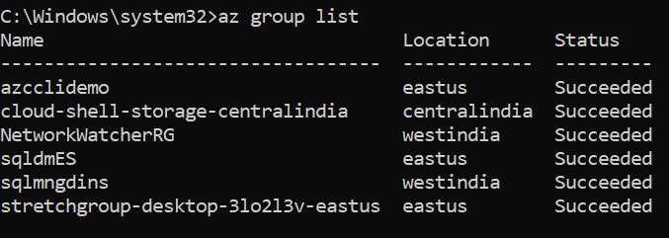

Now to delete Resources group **Azclidemo** type below command and type list command to verify

**az group delete --resource-group azcclidemo --yes --no-wait**

az group list --output table

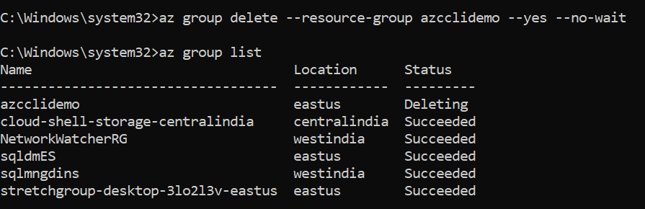

## **Azure VM Comamnd**

Type below command to create a vm name **myVM** in resource group **sqldmES** resource group with default user **demouser**

**az vm create --resource-group "bipeenRG" --name "bipVM" --image "Win2016Datacenter" --admin-username "Vmadmin" --admin-password "Password@123" --location westus2 --storage-sku "Standard_LRS"**

To list all vm type below command

**az vm list --output table**

To stop vm type below command

**az vm stop --resource-group BipeenRG --name BipeenVM**

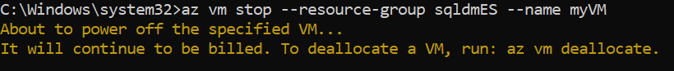

**az vm start --resource-group BipeenRG --name BipeenVM**



**az vm delete --resource-group BipeenRG --name BipeenVM**

